Operational Amplifiers

Amplifier Characteristics
Learning Objectives:

At the end of this topic you should be able to:
- recall the following characteristics of an ideal op-amp:
  - infinite open-loop gain;
  - infinite input impedance;
  - zero output impedance;
  - infinite slew rate;
  - infinite common-mode rejection ratio.
- interpret these characteristics given data for a specific op-amp;
- recognise that the voltage difference between the two inputs of an op-amp with negative
feedback is virtually zero, provided that the output is not saturated;
- explain the meaning of ‘virtual earth’
- recall how the output of an op-amp depends on the relative sizes of the input voltages;

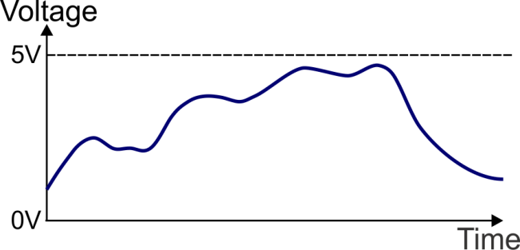
Introduction to Amplifiers

An analogue signal can take on any value between
the highest and lowest voltage present in the electronic
system, as shown opposite.

This topic looks at amplifiers, i.e. devices specifically made to increase the amplitude of signals such as that shown here.

A prime requirement is that it must amplify all parts of the signal equally. If one part is amplified more than another, then the output is not a faithful copy of the input. This effect is called ‘distortion’.

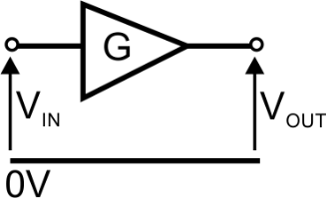
The general symbol for an amplifier is shown opposite:

The voltage gain, G, (or ‘amplification’) of the amplifier is defined as:
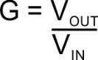
Voltage gain has no units associated with it – it is simply a pure number. A voltage gain of 5 means that the
output voltage, VOUT , is five times bigger than the input voltage, VIN. There are three main categories of amplifiers:
  - voltage amplifiers;
  - current amplifiers;
  - power amplifiers.

This section is concerned only with voltage amplifiers.

The Ideal Operational Amplifier

The operational amplifier, or op-amp, for short, was originally designed to carry out mathematical opera- tions in analogue computers. Now it is widely used in audio systems, for example to boost the output from an electric guitar pickup, or a microphone.

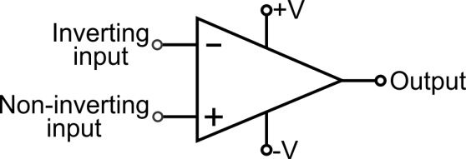
The circuit symbol for an operational amplifier
is shown opposite:

Note: The power supply connections ‘+V’ and ‘–V’, are often left off the circuit diagram to make it easier to follow.

Features:

  - There is one output and two inputs.
  - The ‘+’ and ‘–’ signs on the inputs indicate their relationship to the output and have nothing to do
with power supply connections.
  - There are two power supply connections labelled +V and –V. When used to amplify AC signals, the device requires both a positive and a negative power supply voltage. In other configurations, a single-rail power supply (e.g. 12 V and 0 V) can be connected to +V and –V respectively.
  - Not seen on the circuit symbol are the two ‘offset null’ connections used to cancel out the effect of small internal voltages.

Open-loop Voltage Gain

The op-amp data sheet specifies the voltage gain of the op-amp when used in ‘open-loop’ mode. In this mode, there is no feedback – no signal path between the output of the op-amp and its inputs.

The ‘ideal’ operational amplifier would have an infinite open-loop gain, G0, implying that a significant output voltage would result from an input voltage of virtually zero. In practice, the open-loop gain is usually
>100,000.

The op-amp is designed as a high-gain differential voltage amplifier. This can be expressed as a mathemat- ical equation:
VOUT = G0 × (V2 – V1)
However, there are obvious physical constraints on the validity of this equation. When G0 = 100,000, V2 = 3 V and V1 = 2 V, the output voltage cannot be 100,000 V!
The major constraint is called saturation. The output voltage cannot exceed (or usually, even reach) the
power supply voltages. When the op-amp is powered from a 12 V / 0 V power supply, its output voltage cannot exceed 12 V or 0 V.

Working back from this, the difference in input voltages, (V2 - V1), cannot exceed 12/100,000 V (= 120 μV) without saturating the output. Effectively then, we can say that where the output is not saturated, the two inputs sit at the same voltage. (After all, 120 μV is not far from 0 V!)

Put mathematically, V2 = V1 provided that the output is not saturated.
This gives rise to the concept of virtual earth – when one input is connected directly to 0 V, the other sits at 0 V provided that the output is not saturated.

This is called a virtual earth (‘virtual’ because no current can flow from that input to 0 V).

Other Op-amp Parameters

  - input impedance
‘Resistance’ reduces the flow of electricity in a circuit. ‘Impedance’ can be considered as the equivalent for AC circuits. It determines the current drawn from an input device such as a microphone.
To keep this as small as possible, the input impedance ideally should be infinite.

output impedance
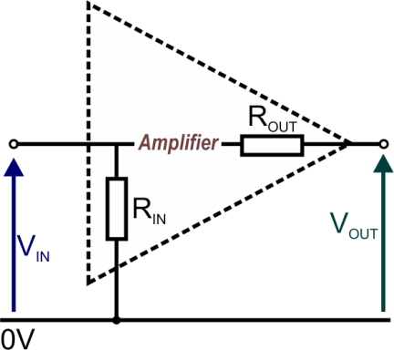
In a similar way, the amplifier provides an output to the remainder of the circuit. We do not want to lose any of the signal in the amplifier itself. An ‘ideal’ op-amp has zero output impedance.

(In a practical op-amp
    - the input impedance is usually > 10 MΩ.
It looks to the outside world as if the amplifier input has a 10 MΩ or so resistor, RIN , connected to the 0 V power rail.
    - the output impedance is around 50~75 Ω.
It is as if a resistor, ROUT , of this size were connected
internally in series with the output.)

slew rate
This measures how well an amplifier responds to a change in input signal. It specifies how rapidly the output voltage can change (in V/s) in response to a change in input voltage.
Ideally, this would be infinite, so that a square wave pulse applied to the input of the amplifier would produce a square wave pulse at the output. When the slew rate is less than ideal, the output voltage ramps up over time, rather than making a sudden change.
(In practice, slew rate is typically a few volts per microsecond. If the slew rate is 5 V/μs, the output
takes 2 μs to change from 0 V to 10 V.
The faster the slew rate, the more accurate the amplifier’s response to high frequency or large amplitude input signals, where the input voltage changes rapidly.)

common-mode rejection ratio (CMRR)
The common-mode rejection measures the ability of the op-amp to reject input signals common to both input leads.
A high CMRR is important where the signals are small voltage fluctuations superimposed on another voltage which appears on both inputs. For example, when measuring the signal from a thermocouple in an electrically noisy environment, the noise signal appears on both input leads.

A high CMRR means that it will have little effect on the output. In an ‘ideal’ op-amp, the CMRR should be infinite. (In practice it varies greatly between op-amps with ratios typically in the range 3,000 to 300,000.)

The following table summarises ideal and practical values for the key op-amp characteristics.

Property | ‘Ideal’ Value | Typical Value
Open-loop gain | Infinite | >100,000
Input impedance | Infinite | >10 MΩ
Output impedance | Zero | 50~75 Ω
Slew rate | Infinite | 0.5 V/µs to 16 V/µs
CMRR | Infinite | 3000–300,000

Feedback
‘Feedback’ means adding a fraction of the output signal to the input signal. When this fraction is returned in phase (in step) with the input signal, it is called ‘positive feedback’. When it is out of phase with the input signal, it is called negative feedback.

Positive feedback: Positive feedback usually causes problems in audio systems. The everyday example is where a microphone is placed too close to the loudspeaker system. A quiet sound picked up by the micro- phone is amplified and played through the loudspeakers. The microphone picks up some of this, adding
to the original sound source and so the sound from the loudspeakers gets louder, as does the proportion
picked up by the microphone ……… The result is a high-pitched squeal.
Positive feedback usually produces either oscillation, as in the microphone example, or saturation, where
the output voltage cannot go any higher (or lower) because of power supply limitations.

Negative feedback: The enormous open-loop gain of the op-amp, essential for most applications, makes it an unstable device. Changes to the power supply voltage, input voltage, device temperature or the presence of electrical noise can cause instability and make the output unpredictable.
Stability is improved by introducing some negative feedback. This uses part of the output signal to reduce
the input signal and, in the process, keeps the amplifier under control.
In contrast to the example of positive feedback, negative feedback is used in ‘noise-cancelling head- phones’. Here, a microphone picks up sounds from the surroundings. An audio system plays an out-of- phase version of these through the headphones to cancel out the external sounds.

Note: The following proof is provided for information only. Its derivation is not required as part of this course.

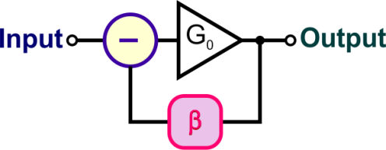
The technique is illustrated in the diagram:
A fraction β of the output voltage is ‘fed back’ to the input,
out of phase, (hence the ‘—’,) with the input signal.

Without feedback, the input voltage VIN produces an output voltage
VOUT, given by: VOUT = G0 × VIN
By some mechanism, a fraction of VOUT is fed back in such a way that it subtracts from the input voltage, reducing it to a new value of input voltage, VIN where:
VIN = VIN - (β × VOUT)
The new output voltage becomes: VOUT = G0 × VIN
Replacing VIN with the value obtained from the second equation gives:
VOUT = G0 × (VIN - (β × VOUT))
Rearranging this: VOUT (1 + G0 β) = G0 VIN
Using negative feedback, the new voltage gain is:
G = VOUT
VIN

Assuming that G0
is much greater than 1, this = G0 reduces to: G ≈ 1
1 + G0β β

The significance of this is that the voltage gain depends entirely on the feedback fraction β and is not
affected by the open-loop gain of the op-amp.

The benefits of negative feedback include:
  - reduced distortion;
  - reduced sensitivity to external changes – power supply fluctuations etc.;
  - increased bandwidth;
  - improved input and output impedance.

Bandwidth
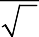
Learning Objectives:

At the end of this topic you should be able to:
recall that the bandwidth is the frequency range over which the voltage gain is greater than 1 (70%) of its maximum value;
2
estimate this bandwidth from a frequency response curve;
use the gain-bandwidth product (unity-gain bandwidth) to estimate bandwidth.

Introduction

An important theorem in electronics says that any periodic signal (one which repeats the same waveform over a period of time) can be made by adding together a number of sine waves of different frequencies and amplitudes. Different waveforms contain different mixes of sine waves.

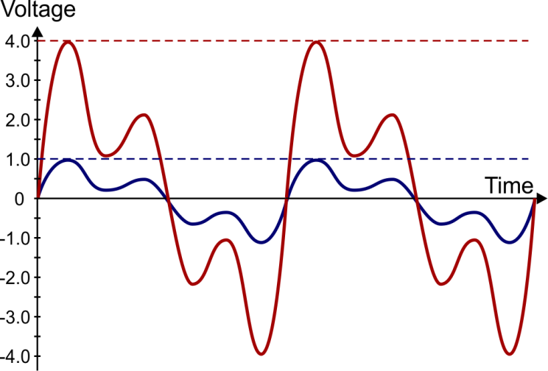
Exactly what mix of sine waves a signal contains is shown by its frequency spectrum, a graph of voltage against frequency.

Ideally, a voltage amplifier should:

  - increase the amplitude of the input signal;
  - leave unchanged the frequency content of
the signal (i.e. its frequency spectrum).

This is illustrated in the diagrams opposite:
In the upper diagram, the input signal (shown in blue) is amplified with a voltage gain of four to give the corresponding output signal (shown in red.)
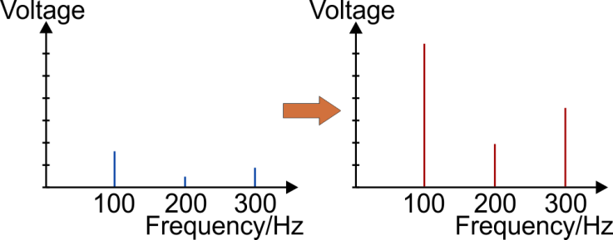
The output is a precise copy of the input, with
an amplitude four times bigger.
The lower diagrams show the effect of the
amplifier on the frequency content of the
input signal. (They show the frequency spectra of the input and output signals.)
Each frequency component is treated equally.

Putting this requirement another way, ideally the amplifier should cause no distortion of the input signal. One measure of how well this is met is given by the bandwidth of the amplifier. This measures the range of frequencies that can be amplified successfully (i.e. with negligible distortion.)
The slew rate of the amplifier can also be an issue. Where the output voltage cannot move sufficiently rapidly, it cannot reproduce the waveform of the signal accurately. Slew rate is significant for high frequency (i.e. rapidly changing) components of the signal.

Amplifier Bandwidth

Speech signals use a frequency range of 0 to 3.5 kHz, audio signals 0 to 20 kHz and video signals 0 to 6 MHz. It is not possible to design an amplifier to cover the entire frequency band. As a result, there are devices called audio amplifiers, radio frequency amplifiers, etc. that are designed to cope with signals

containing a specific range of frequencies.

This ability is described by the bandwidth of the amplifier.

The bandwidth is defined as the frequency range over which the voltage gain is greater
than 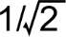 (approximately 70%) of its maximum value.

The bandwidth is the frequency range between:
  - the upper frequency – where the voltage gain has dropped to 70% of its peak value;
  - the lower frequency – where the voltage gain has dropped to 70% of its peak value.

Example 1:

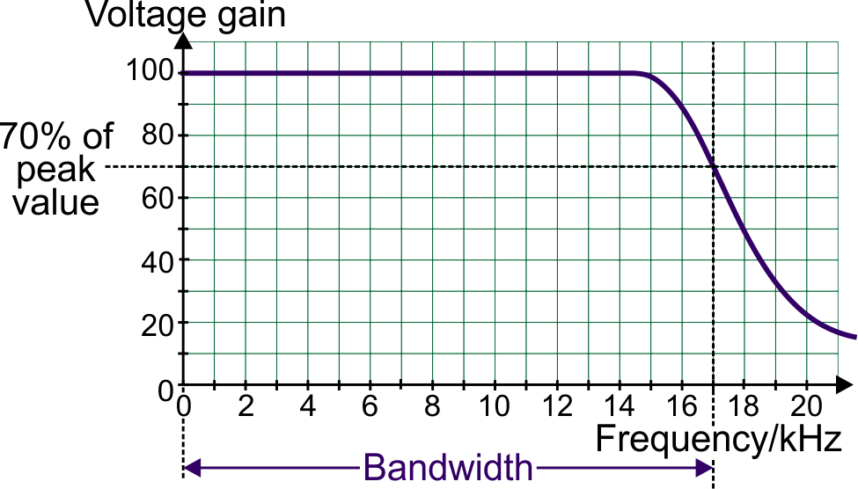
An audio amplifier has the frequency response shown in the following graph. Estimate the bandwidth of the amplifier.
(In many cases, we assume that
the performance of a well-designed amplifier has the shape shown in the graph.)

Peak value of voltage gain = 100. 70% of this peak gain = 70.

The procedure:

  - Draw a horizontal line on the graph from a voltage gain of 70.
  - Drop a vertical line at the frequency where this line crosses the frequency spectrum.

This gives the upper frequency limit of performance. The lower frequency limit is 0 kHz.

Hence, the amplifier has a bandwidth of 17 kHz.

Gain-bandwidth Product

The bandwidth of an amplifier is closely linked to the voltage gain of the amplifier – the higher the voltage gain, the smaller its bandwidth.
This leads to a parameter called the gain-bandwidth product (GBP), sometimes called the unity-gain bandwidth. This is virtually constant for any particular amplifier.

For example, the TL081 op-amp has a gain-bandwidth product of 4 MHz (or 4000 kHz). Using negative feedback, we can control the voltage gain to a value of our choosing. In doing so, we also determine the bandwidth of the resulting amplifier, as the table shows:

Voltage gain | GBP (kHz) | Bandwidth (kHz)
1 | 4000 | 4000
10 | 4000 | 400
100 | 4000 | 40
400 | 4000 | 10

Note: Amplifier power supplies

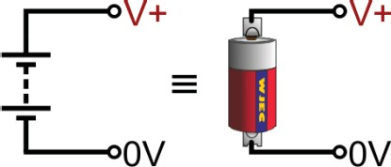
  - When the op-amp is configured as a comparator, for example, a ‘single-rail’ power supply is used. This provides two voltage rails – a positive rail and a 0 V rail – as if a single battery was connected as shown in the upper diagram.

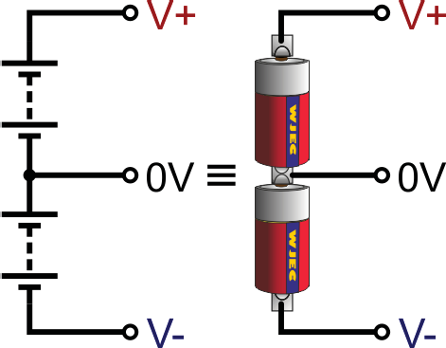
  - When used to amplify AC signals, a ‘dual-rail’ power supply is used. This provides three voltage rails – a positive rail, a 0 V rail and a negative rail – as if two batteries were connected as shown in the lower diagram. For example 15 V dual-rail power supply is often written as ± 15 V.

Exercise 4.1

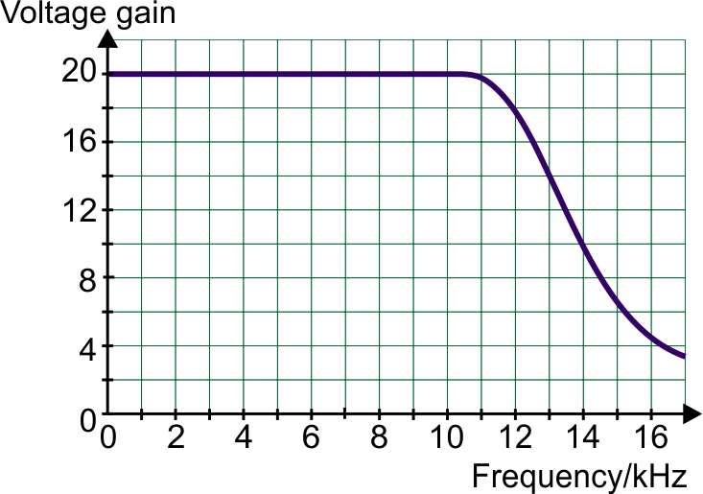
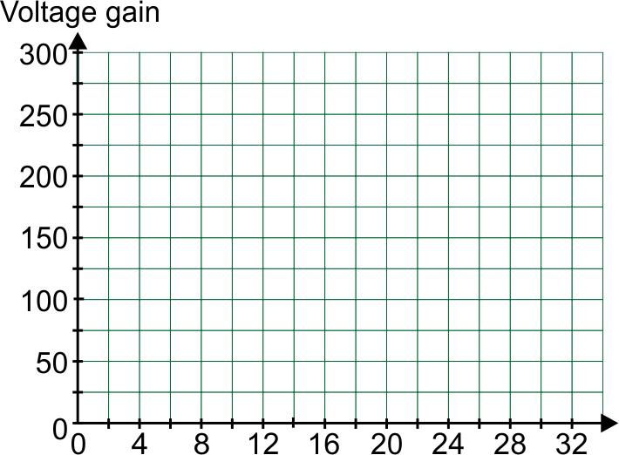
- The frequency spectrum for an audio
amplifier is shown opposite.

Use the graph to estimate the bandwidth
of the amplifier.

Bandwidth = kHz

- An amplifier with a voltage gain of 200, has a bandwidth of 20 kHz.
Use the axes provided to sketch the
frequency response of the amplifier.

- The CA 3130 op-amp has a gain-bandwidth product of 15 MHz.
Voltage gain | Bandwidth (kHz)
1
 | 30
100
 | 250

Complete the table for a voltage amplifier using a CA 3130 op-amp, by calculating missing values.

- Here is some data about two op-amps,
Property | X | Y
Open-loop gain | 4 × 10⁵ | 1 × 10⁵
Gain-bandwidth product / MHz | 3 | 0.6

X and Y.

- Which op-amp would have a bandwidth of 6 kHz when configured to have a voltage gain of +500?

.....................
- Give a reason for your answer:

..............................................................................................................................

..............................................................................................................................

The Inverting Amplifier
use the rule of thumb that the input impedance is equal to the resistance of the input
resistor;
design an inverting amplifier using negative feedback to achieve specified voltage gain.
RIN
VIN
R
V
G = OUT = − F
select and use the formulae:
Learning Objectives:

At the end of this topic you should be able to:
draw and recognise the inverting voltage amplifier circuit;
draw and interpret graphs for the response of an inverting amplifier to AC and DC input signals;

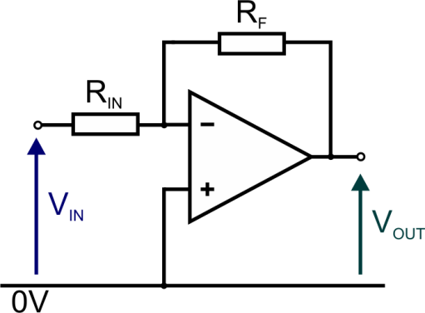
The circuit diagram for the inverting amplifier is:

Features:

  - Feedback is delivered through the resistor, RF, connected between output and input.
  - As this feedback is delivered to the inverting input, this is negative feedback.
  - The voltage gain, G, of this amplifier is given by the following formulae.

G = VOUT
VIN
= − RF
RIN

  - Voltage gain can be determined either from VOUT and VIN, or from RF and RIN.
  - The input signal is applied to the inverting input, through an input resistor, RIN. This gives the amplifier its inverting action – a positive input voltage produces a negative output voltage and vice
versa.
  - The ‘–’ sign in the formula confirms this inverting action.
  - Provided the output is not saturated, both inputs sit at the same voltage. Since the non-inverting input is connected directly to 0 V, the inverting input acts as a virtual earth.
  - The input impedance of this amplifier is taken to be equal to the value of RIN.
  - This circuit is usually powered from a dual-rail power supply giving, for example, +12 V, 0 V
and –12 V.
  - When designing an amplifier like this, all resistors should be greater than 1 kΩ.
  - For most applications, the non-inverting amplifier (that follows) has superior characteristics to those of the inverting amplifier. In reality, inverting amplifiers are used in a limited number of applications, such as tone controls and audio mixers.

The graphs on this page show the behaviour of an inverting amplifier with a voltage gain of –3.

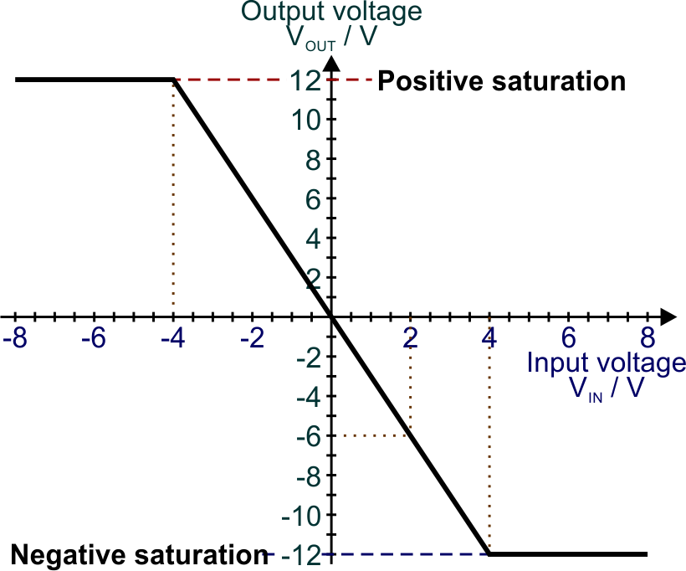
The top graph is called the characteristic curve and shows how the output voltage depends on the input voltage

Its gradient on the sloping section is equal to the voltage gain of the amplifier.

A gain of –3 means that when the input voltage is +2 V, the output voltage is –6 V. (This is shown on the upper graph.)

There is a maximum (and minimum) output voltage. These depend on the precise characteristics of the op-amp and on the power supply voltage used. This graph assumes that saturation occurs at +12 V and –12 V, often written as (±12 V) .

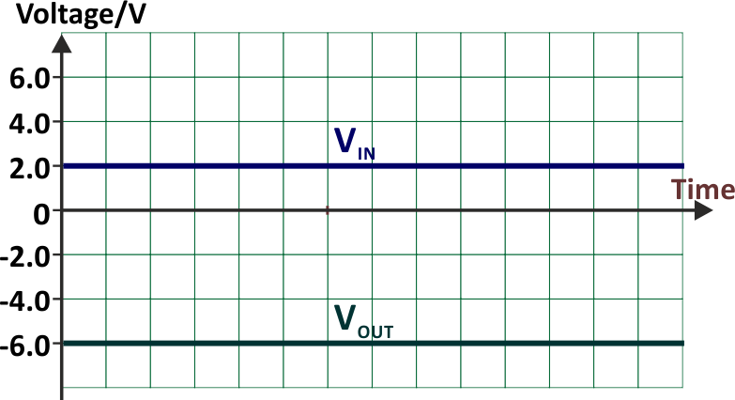
When the output reaches this maximum value, it is said to have reached ‘positive saturation’. Similarly, ‘negative saturation’ occurs when the output reaches the minimum possible voltage.

The next graph shows the response of the
amplifier to a steady +2.0 V DC signal.

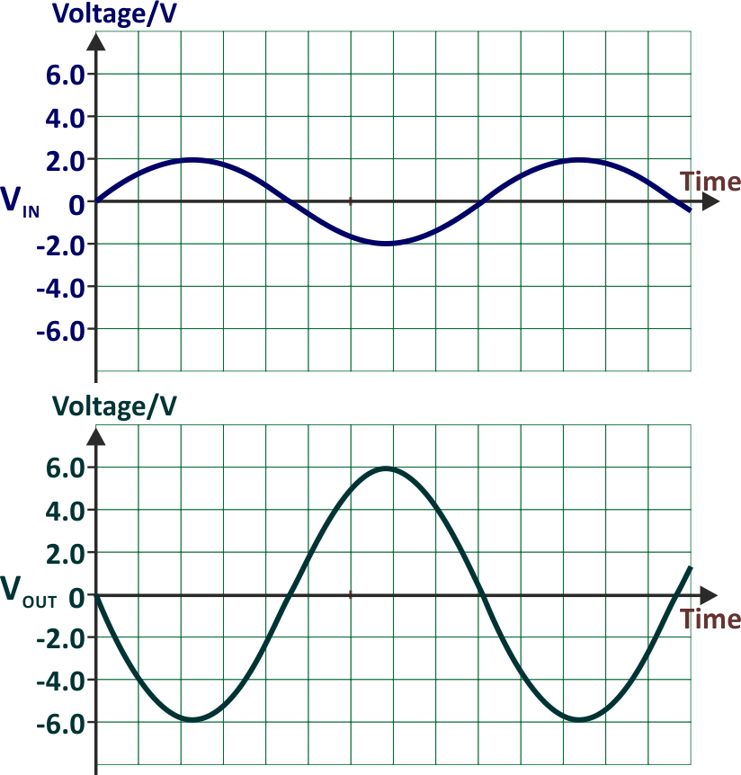
The corresponding output is a steady –6.0 V signal, assuming that the output does not saturate at a lower voltage.

The bottom graphs show the effect on a
sine wave signal with a peak value (amplitude) of 2 V.

Again, it is assumed that the output is never
saturated.

The waveform is inverted – when the input is
at +2.0 V, the output is at –6.0 V, etc.

The time period and frequency are unchanged.

Example 1:

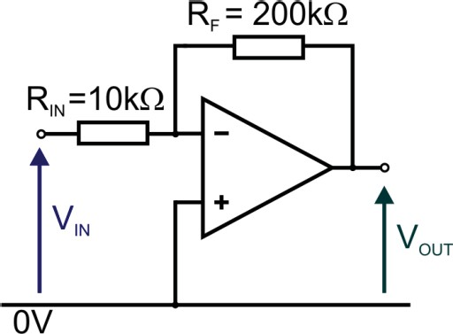
An inverting amplifier requires a voltage gain of –20 and an input impedance of 10 kΩ. Draw the circuit diagram for the amplifier and determine suitable values for the resistors.
kK
kK

The question specifies that the input impedance must be 10 kΩ.
This means that RIN must be equal to 10 kΩ.
Using the voltage gain formula:
G = − RF
RIN
−20 =− RF
10
RF = 200 kK

The results are given in the circuit diagram opposite.

Example 2:

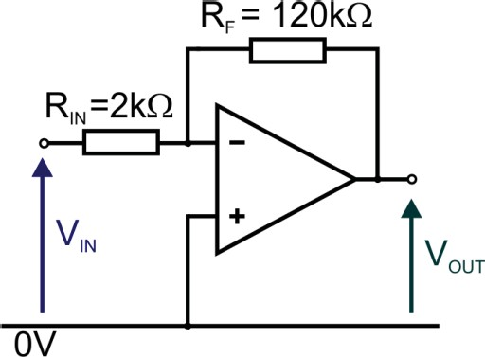
The diagram shows the circuit for an amplifier. It is connected to a ±10 V power supply.
kK
kK

- For this amplifier, determine:
  - the voltage gain;
  - the input impedance;
  - the output voltage when the input = 100 mV.

- Using the voltage gain formula:

G = − RF
RIN
G = − 120
2
G = − 60

The voltage gain = – 60

- Input impedance = resistance of the input resistor = 2 kΩ

- Using the voltage gain formula:

G =

VOUT VIN

− 60 =
VOUT 100×10 ⁻³

VOUT = − 6 V

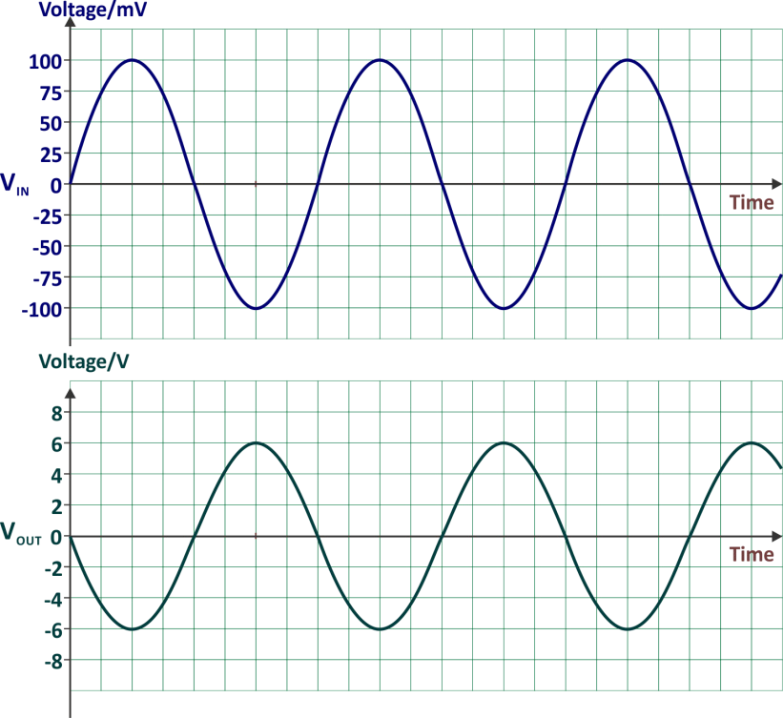
- The top graph shows the input
signal, VIN.
On the axes provided, sketch the corresponding output signal, VOUT .

Features of the solution:

- peak output voltage (6 V) = peak input voltage (100 mV) × voltage gain (60);
- output signal is inverted (effect of inverting
amplifier);
- signal frequency is unaffected.

Example 3:

The graphs opposite show input and output signals for a voltage amplifier.

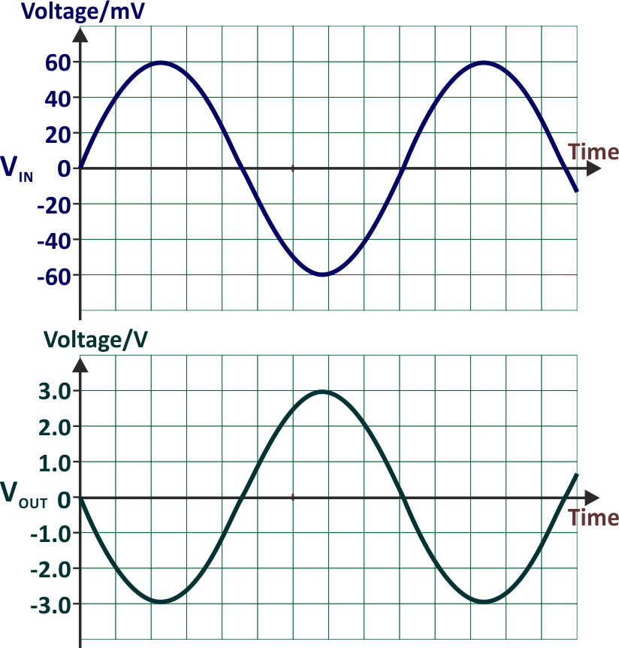
Draw the circuit diagram for an amplifier which would generate this response to the input signal shown.

Determine suitable values for all resistors used in the circuit.

The design rationale is as follows:

- It is an inverting amplifier, the output waveform is out of phase with the input.
- Since 60 mV = 0.06 V,
the voltage gain = –3 / 0.06 = –50
- Using the voltage gain formula:
G = − RF
RIN
− 50 = − RF
RIN
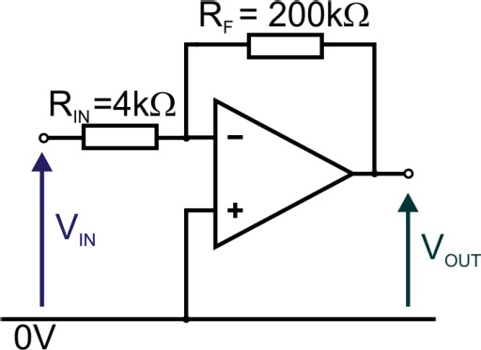
All resistors must be >1 kΩ. The essential requirement is the resistor ratio. There is a host of correct solutions
kK
kK

with this ratio, for example RF
= 200 kΩ and RIN
= 4 kΩ.

One possible solution is shown opposite:

Investigation 4.1

Set up the inverting amplifier shown below using a TL081 (or equivalent) op-amp connected to a ± 9 V
power supply.
kK
kK

- Connect a 100 mV DC voltage to VIN and confirm that the value of VOUT is –6 V.
- Remove the 100 mv DC input and replace it with a function generator set to produce a 1 kHz sine wave output of amplitude 100 mV. Use an oscilloscope to observe both VIN and VOUT.
Compare the result with the graph provided in sample design 2 above.

Note:

With a dual-trace oscilloscope, you can observe VIN and VOUT simultaneously, adjusting the controls of each channel independently to see each signal clearly.

If using ‘Circuit Wizard’ to simulate the circuit, the dual-trace oscilloscope does not allow independent adjustment of the two signals. As a result, either the input appears too small or the output too large to observe clearly. This difficulty can be overcome by using a separate oscilloscope to observe each channel.

Exercise 4.2

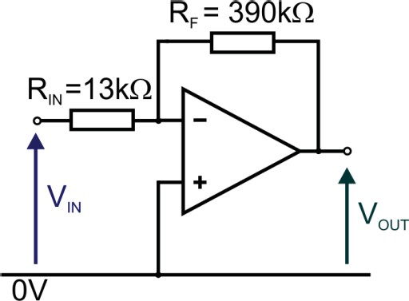
- The diagram shows an inverting amplifier circuit.
kK
kK

  - Determine:
    - the voltage gain of the amplifier;
    - its input impedance;
    - the output voltage when the input = 300 mV.

- The voltage gain:

- The input impedance:

- The output voltage:

  - The top graph shows the input signal, VIN. On the axes provided, sketch the corresponding
output signal, VOUT. Label the graph of VOUT with suitable values.
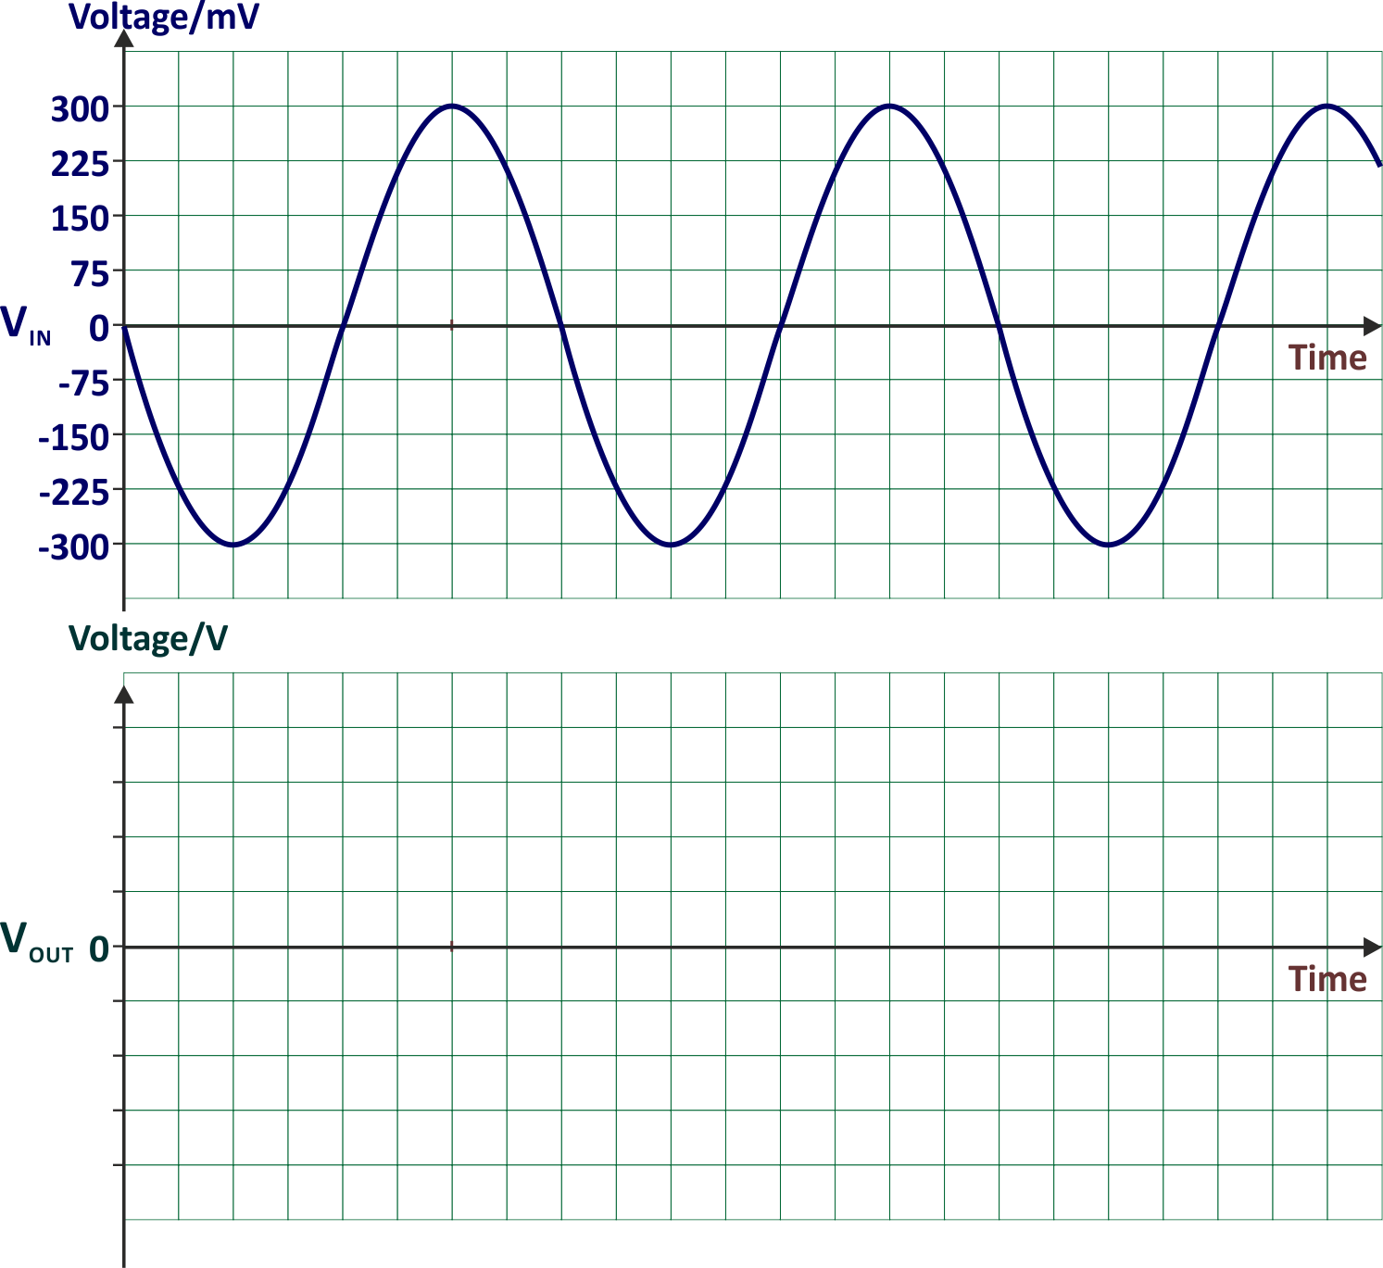

- An inverting amplifier is used in an electric guitar pickup.

The amplifier requires a gain of –400 and an input impedance of 2 kΩ.

Draw the circuit diagram for the amplifier and determine suitable values for the resistors.

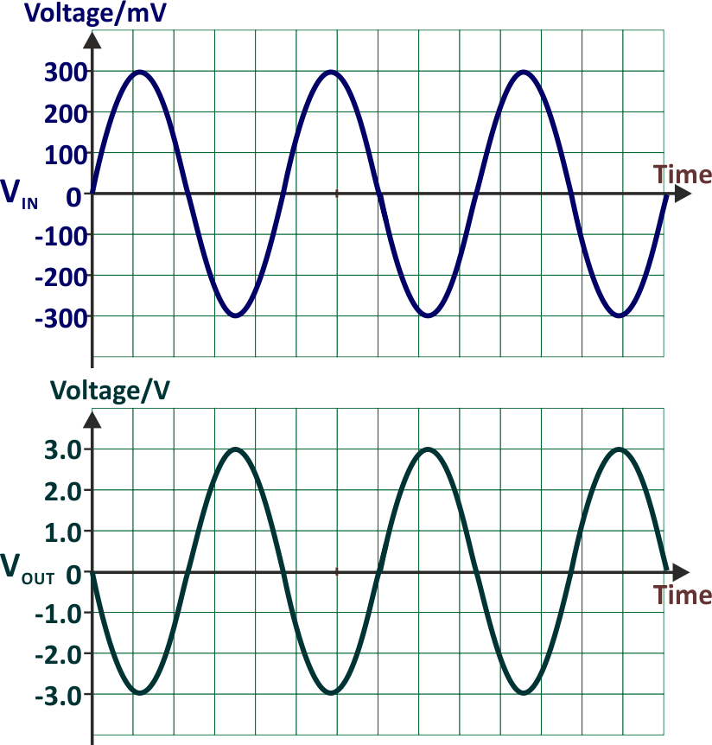
- Design an amplifier which would generate the output signal shown in the lower graph when the input signal is that shown in the upper graph.
Draw the circuit diagram for the amplifier. Determine suitable values for all resistors
used and add these values to the circuit
diagram.

The Non-Inverting Amplifier
recall that the input impedance of a non-inverting amplifier is equal to that of the op-amp;
design a non-inverting amplifier using resistive negative feedback to achieve specified voltage gain.
R1
VIN
R
V
G = OUT = 1+ F
select and use the formulae:
Learning Objectives:

At the end of this topic you should be able to:
draw and recognise the non-inverting voltage amplifier circuit;
draw and interpret graphs for the response of a non-inverting amplifier to AC and DC input signals;

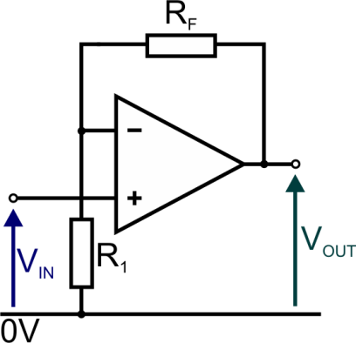
The circuit diagram for the non-inverting amplifier is:

Features:

- Feedback is delivered through the resistor RF, connected between output and input.
- As this feedback is delivered to the inverting input, this is negative feedback.

VOUT
G =
- The voltage gain is given by:
V
IN

= + RF
R₁
1

- Voltage gain can be determined either from VOUT and VIN, or from RF and R1.
- The input signal is applied directly to the non-inverting input, giving the amplifier a non-inverting
action – a positive input voltage produces a positive output voltage, etc.
- The gain is positive with a minimum gain of +1, when RF = 0.
- Provided the output is not saturated, both inputs sit at the same voltage, equal to the input voltage in
this case.
- The input impedance of the amplifier equals the input impedance of the op-amp itself.
- This circuit is usually powered from a dual-rail power supply giving, for example, +12 V, 0 V and
–12 V (i.e. ±12 V).
- When designing an amplifier like this, all resistors should be greater than 1 kΩ.

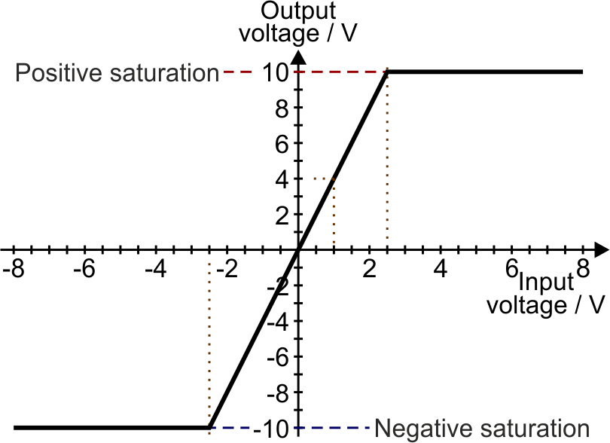
The graphs below show the behaviour of a non-inverting amplifier with a voltage gain of 4.

The characteristic curve shows how the
output voltage depends on the input voltage.
Again, its gradient on the sloping section
is equal to the voltage gain of the amplifier. A gain of 4 means that when the input voltage is +1 V, the output voltage is +4 V (as shown on the upper graph).
There is a maximum (and minimum) output voltage. These depend on the precise characteristics of the op-amp and on the power supply voltage used. This graph assumes that saturation occurs at +10 V and –10 V.

‘Positive saturation’ occurs when the output reaches the maximum possible value and ‘negative saturation’
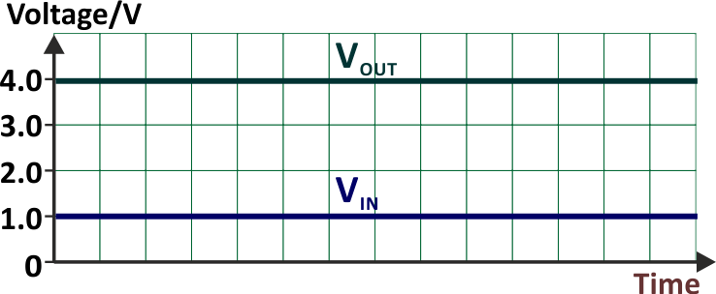
when it reaches the minimum possible voltage.

The next graph shows the response of the
amplifier to a steady +1.0 V DC signal.

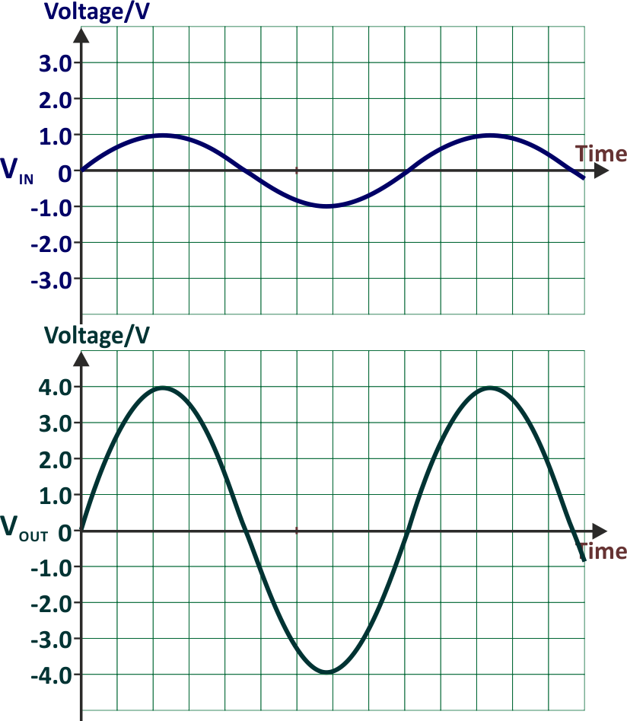
The corresponding output is a steady +4.0 V signal, assuming that the output does not saturate at a lower voltage.

The bottom graphs show the effect on a
sine wave signal of peak voltage (amplitude)
of 1 V, assuming that the output never saturates.

The waveform is not inverted. An input of
+1.0 V produces an output of +4.0 V, etc.

The time period and frequency are unchanged.

Example 1:

A non-inverting amplifier is used as a preamplifier for a microphone. The amplifier requires a gain of +100. Draw the circuit diagram for the amplifier and determine suitable values for the resistors.

Using the voltage gain formula:
G = 1 + RF
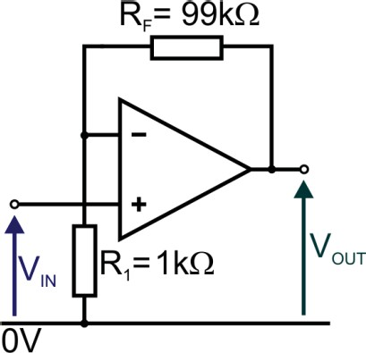
R1
kK
kK

100 = 1 + RF
R1
RF = 99 +R1

We can choose any values that have this ratio as long as both are greater than 1 kΩ.

The results, given in the circuit diagram opposite, take the
smallest possible values that meet the design specification.

Example 2:

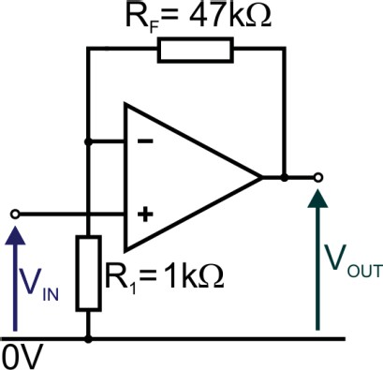
The diagram shows the circuit for an amplifier. The input impedance of the op-amp is 15 MΩ.
kK
kK

- Determine:
  - the voltage gain of the amplifier;
  - the input impedance of the non-inverting amplifier;
  - the output voltage when the input = 50 mV.

- Using the voltage gain formula:
G = 1 + RF
R1
G = 1 + 47
1

G = 48

The voltage gain of the amplifier is 48.

- Input impedance = impedance of op-amp = 15 MΩ

- Using the voltage gain formula:
G = 48 =

VOUT VIN
VOUT

50 ×10 ⁻³

VOUT = 2.4 V

When the input = 50 mV, the output voltage = 2.4 V

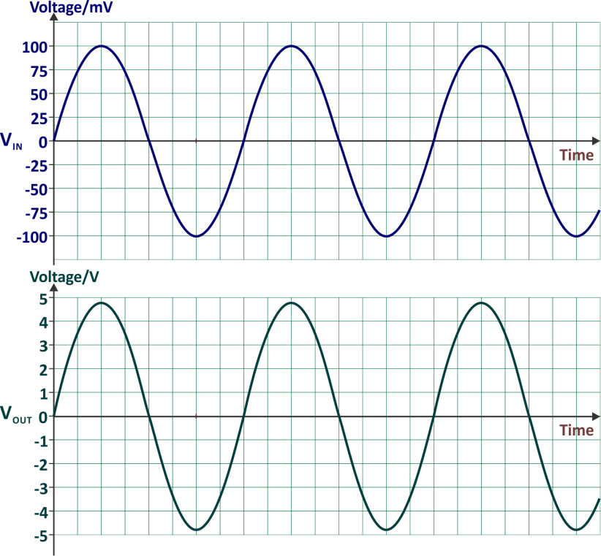
- The top graph shows the input
signal, VIN .
On the axes provided, sketch the corresponding output signal, VOUT .

Features of the solution:

- peak output voltage (4.8 V) = peak
- input (100 mV) × voltage gain (48);
- output signal is not inverted (non-inverting
amplifier);
- frequency is unaffected.

Example 3:

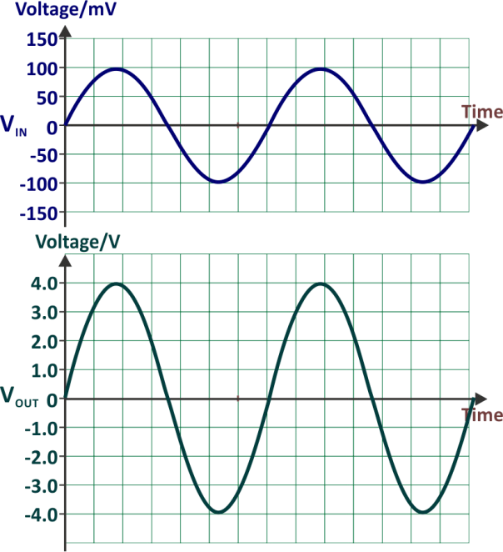
The graphs opposite show input and output
signals for a voltage amplifier.
Design an amplifier which would generate this response.
Calculate suitable values for all resistors used and draw the circuit diagram for the amplifier with these values included.

The design rationale:

- It is a non-inverting amplifier – the output waveform is in phase with the input.
- The input peaks at 100 mV (= 0.1 V). The output peaks at 4.0 V.
The voltage gain = 4.0 / 0.1 = 40
- Using the voltage gain formula:

G = 1 + RF
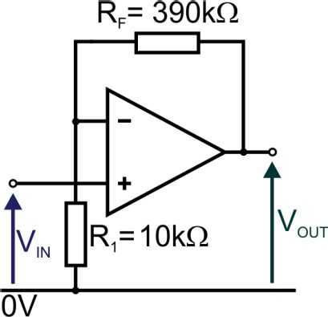
R1
kK
kK
40 = 1 + RF
R1
RF = 39 R ₁
RF= 39 × R 1
All resistors must be >1 kΩ. One possible solution
uses RF = 390 kΩ and R1 = 10 kΩ, as shown opposite:

Investigation 4.2
kK
kK

Set up the non-inverting amplifier shown on the right using a LM358 (or equivalent) op-amp connected to a ± 9 V power supply.

- Connect a function generator set to produce a 5 kHz sine wave output of amplitude 100 mV.
Use an oscilloscope to observe both VIN and VOUT.
Compare the result with the graph provided in example 3 above.

- Complete the table below by recording the values of VOUT and Gain at each frequency.

Frequency/kHz | VIN/mV | VOUT/V | Gain
5 | 100
10 | 100
15 | 100
20 | 100
25 | 100
30 | 100
35 | 100
40 | 100

- Calculate the voltage gain of the amplifier at each frequency and use your results to plot the
frequency response on the grid below:

- Use the graph to determine the bandwidth of the amplifier

- Calculate the gain bandwidth product of the LM358 op-amp and compare the value with that provided on its data sheet.

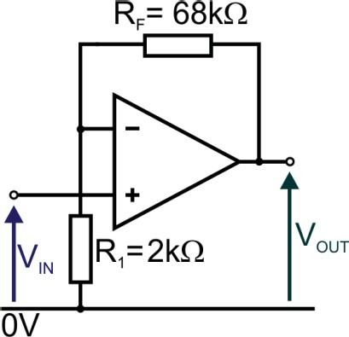
Exercise 4.3
kK
kK

- The following diagram shows a non-inverting amplifier circuit. The input impedance of the op-amp is 20 MΩ.

  - Determine:
    - the voltage gain of the amplifier;
    - its input impedance;
    - the output voltage when the input = 75 mV.

- The voltage gain:

- The input impedance:

- The output voltage:

  - The top graph shows the input signal, VIN. On the axes provided, sketch the corresponding
output signal, VOUT . Label the graph of VOUT with suitable values.
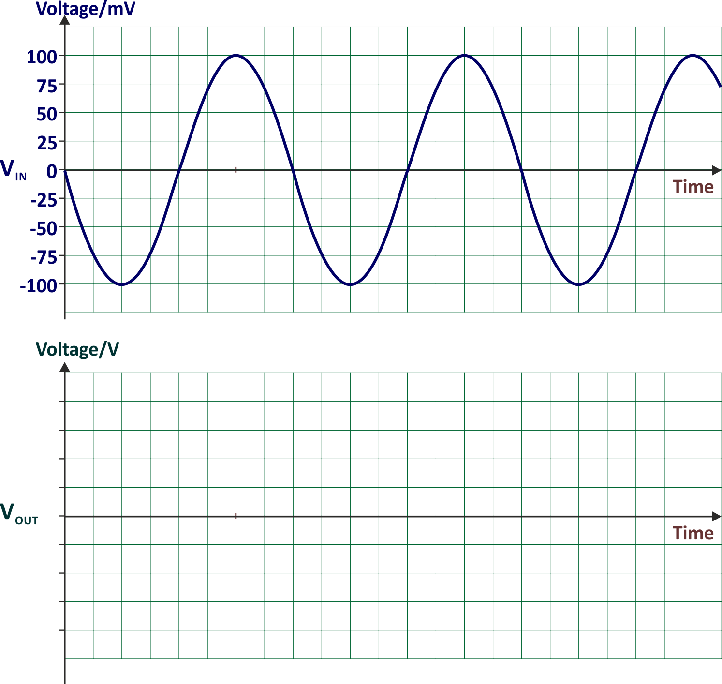

- A non-inverting amplifier is used as a preamplifier for a microphone in a public address system. The amplifier requires a gain of +40.

Draw the circuit diagram for the amplifier and determine suitable values for the resistors.

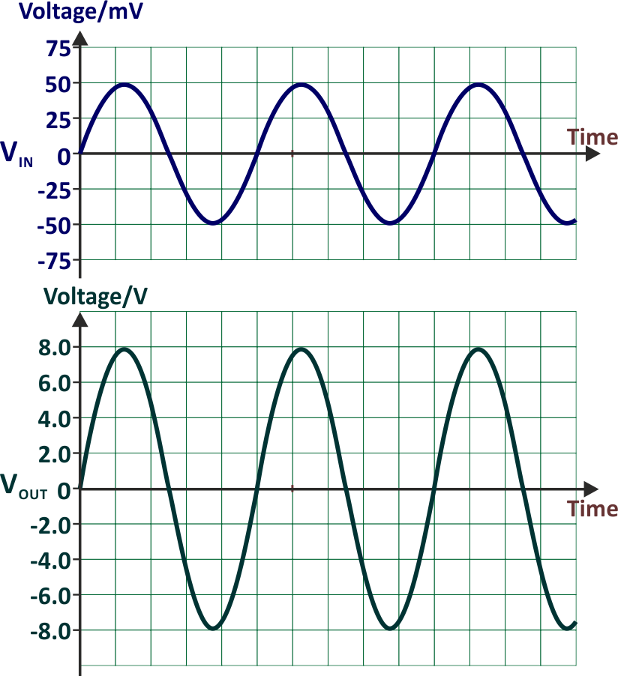
- Design an amplifier which would generate the output signal in the lower graph for the input signal in the upper graph.
Draw the circuit diagram for the amplifier. Determine suitable values for all resistors
used and add these values to the circuit
diagram.

The Summing Amplifier
⎠
⎟
R2
⎝ R1
⎞
V
2
++ ....
1
⎛ V
F ⎜
= −R
OUT
select and use the formula: V
Learning Objectives:

At the end of this topic you should be able to:
draw and recognise the summing amplifier circuit;
The circuit diagram for a three-channel summing
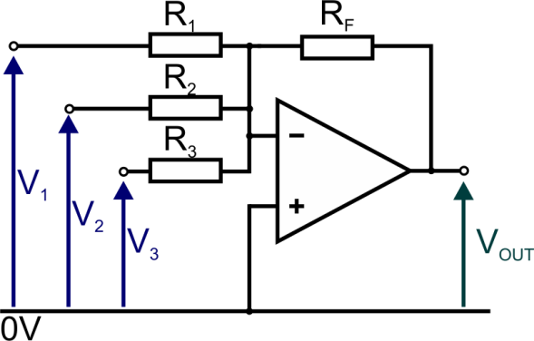
amplifier is:

Features:
  - The summing amplifier has a number of uses, including as an audio mixer and as a digital-to- analogue converter (DAC.)
  - As before, negative feedback is delivered through the resistor RF.
  - Provided the output is not saturated, both the inverting and non-inverting inputs sit at the same
voltage. Since the non-inverting input is connected directly to 0V, the inverting input acts as a virtual earth.

  - The output voltage gain is calculated using the formula: V
1 2

= −R
⎛ V V
⎜ 1 + 2
+ ....⎞

  - The circuit is a multiple-input inverting amplifier.
⎟
OUT F ⎝ R R ⎠

  - The output is the sum of the outputs of the individual inverting amplifiers:

The gain formula can be rewritten as:

V = −R
⎛ V V
⎜ 1 + 2
+ ....⎞

OUT F ⎝ R R ⎠
⎟
1 2
⎛ V ⎞ ⎛ V ⎞
V = ⎜ −R × 1 ⎟ + ⎜ −R × 2 ⎟ + ....
⎝
F
F

OUT
1 2
R ⎠ ⎝ R ⎠

For an inverting amplifier with input voltage V1 and gain G1, the inverting amplifier gain formula can

be rewritten as:
G = VOUT = − R F

V1 R1

V = − R
- V1

OUT F
R
1

Comparing these, you see that the output of the summing amplifier is equal to the sum of the separate inverting amplifier outputs.

  - This circuit is usually powered from a dual-rail power supply giving, for example +12 V, 0 V and
–12 V, (i.e. ±12 V).
  - When designing an amplifier like this, all resistors should be greater than 1 kΩ.

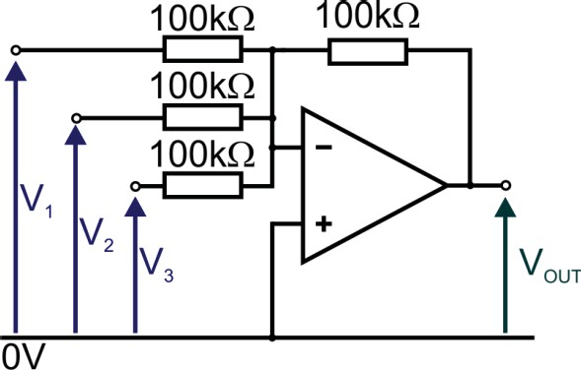
Example 1:
kK
kK
kK
kK

The circuit diagram for a summing amplifier is
shown opposite:

The input voltages are:
    - V1 = +1 V;
    - V2 = +2 V;
    - V3 = +3 V.
The output is not saturated. Calculate the output voltage.

Using the formula:

V = −R
⎛ V V
⎜ 1 + 2
+ ....⎞

OUT F ⎝ R R ⎠
⎟
1 2

V = −100 ⎛ 1 +

2 + 3 ⎞



OUT
⎝ ⎠

VOUT = −6V
⎜ 100 100 100 ⎟

(The ‘k’s have been omitted as they cancel out eventually.)

Note: - The output is the arithmetic sum of the inputs – it is a summing amplifier after all – but is inverted. (This is true only because all resistors have equal values.)

Example 2:

Design a summing amplifier which produces an output that satisfies the equation:
VOUT = (V1 + 2V2)
The summing amplifier is a form of inverting amplifier and so gives:
VOUT = – (V1 + 2V2)
The design must invert the output of the summing amp. To do this, the summing amplifier should have:
a voltage gain of 1 on input 1 – so that RF / R1 = 1; a voltage gain of 2 on input 2 – so that RF / R2 = 2.
Choosing values RF = 200 kΩ, R1 = 200 kΩ and R2 = 100 kΩ satisfies these requirements. To invert the output of a summing amplifier, we add an inverting amplifier with a gain of –1.
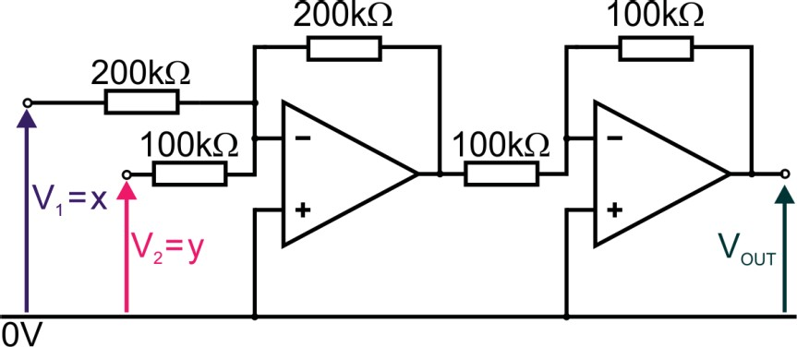
The inverting amplifier must have equal feedback and input resistors, say 100 kΩ for each. The final circuit is:
kK
kK
kK
kK
kK

(There is a practical limit on how big the input voltages can be. The output of the summing amplifier must not saturate.)




Investigation 4.3
kK
kK
kK

Set up the summing amplifier shown opposite using a TL081 op-amp:

- Adjust input voltages to the following values:
  - V1 = +3 V
  - V2 = +2 V
- Measure VOUT …………………………
- Remove the 3 V DC input connected to V1 and replace it with a function generator set to produce
a 1 kHz sine wave output with an amplitude of 3 V.

Leave V2 at +2 V DC.
- Use an oscilloscope to observe VOUT and sketch the result on the axes below.
Label the voltage axis to indicate the peak values of VOUT.
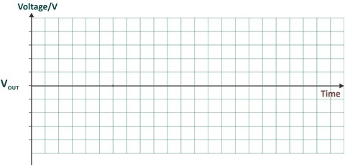

Exercise 4.4

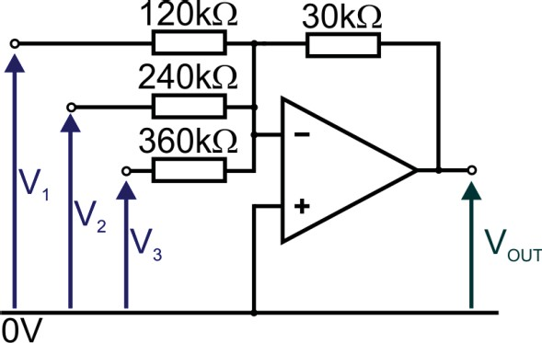
- The circuit diagram for a summing amplifier is
kK
kK
kK
kK
shown opposite:

The input voltages are:

V1 = V2
= V3
= +6 V.

The output is not saturated. Calculate the output voltage.

- Design a two-channel summing amplifier which produces an output voltage which is half the size of the sum of its input voltages. The maximum input voltage is +10 V.

Draw the circuit diagram for the amplifier and determine suitable values for the resistors.

The Voltage Follower
Learning Objectives:

At the end of this topic you should be able to:

- draw and recognise the voltage follower circuit;
- recall the use of a voltage follower for impedance matching;
- select and use the formula: VOUT = VIN

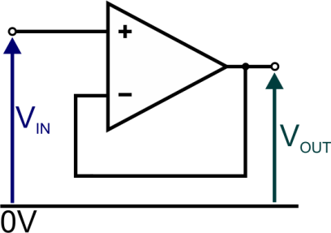
The circuit diagram for a op-amp voltage follower is shown opposite:

Features:
  - The voltage follower is a form of non-inverting amplifier.
  - The circuit uses negative feedback but there is no feedback resistor – the feedback resistance is
ideally 0 Ω.
  - Similarly, R1 has been removed. The input resistance is ideally infinite.
  - Using the voltage gain formula for the non-inverting amplifier gives:
G = 1 + RF
R1
G = 1 + 0

◎
G = 1
In other words, VOUT = VIN.
  - Another way to view this is to return to the basic equation of the op-amp:
VOUT = G0 × (V2 – V1)
As was shown earlier, when the output is not saturated, the two inputs sit at the same voltage, i.e.
V2 = V1.
In this case:
    - V2 is equal to the input voltage VIN;
    - V1 is equal to the output voltage VOUT, as it is connected directly to it.
Hence, as before, VOUT = VIN.
  - The importance of the voltage follower lies in its effect in ‘impedance matching’.

Suppose that an electronic system has an output device ‘Y’, receiving a signal from sub-system ‘X’.
Y has a low resistance and requires a large current to make it function.
However, X has a fairly high resistance and can deliver only a small current.

Connected as in A, there are problems! X cannot deliver enough current to make Y operate properly.

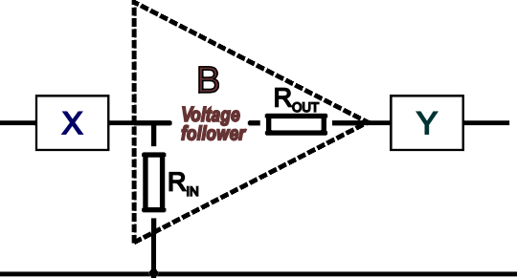
When a voltage follower is connected in between the two, as in B, the situation is much improved.

Sub-system X delivers a signal to the op-amp. It ‘sees’ the full input resistance of the op-amp
– several megohms usually. It can cope with the small current that the op-amp demands.

Equally, Y receives its signal through the relatively small output resistance of the op-amp, typically 75 Ω. The latter has a much smaller effect on current than X and sufficient current flows to make Y operate properly.
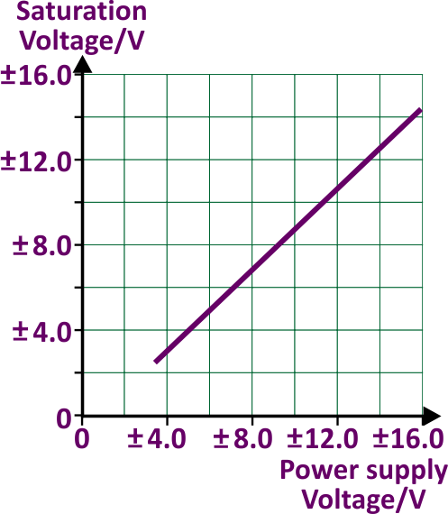

Signal Distortion
slew rate = 2 πf VP
•
ΔVOUT
Δt
slew rate =
Learning Objectives:

At the end of this topic you should be able to:
recognise clipping distortion, and describe how it can be reduced by:
increasing the supply voltage;
reducing the voltage gain;
reducing input amplitude.
use the output saturation voltage to calculate the maximum input voltage before clipping
distortion occurs;
recognise slew rate distortion for:
a step input signal;
a high frequency sinusoidal input signal.
select and apply the equations:

Clipping Distortion

It was pointed out earlier that the output of an amplifier cannot increase indefinitely. It is limited by the power supply voltages used to power the amplifier.
In most cases, the output saturates before it reaches the power supply voltages. How close it gets to the power supply voltage depends on the op-amp used.
The first graph shows how these are related for the TL081
op-amp, which has a maximum power supply voltage of ±18 V. The second graph shows the effect of saturation.
Here, an amplifier in theory produces an output voltage that peaks at ±16 V.
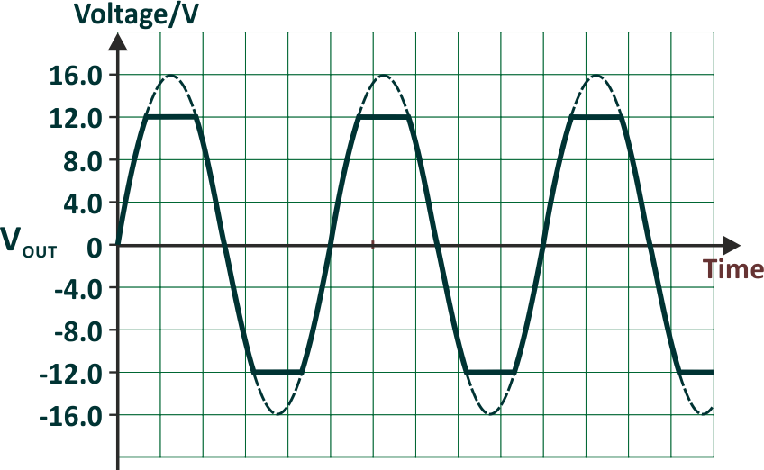
In practice, the output of this amplifier saturates at ±12 V. Instead of the waveform increasing all the way to 16 V, it ‘clips’ at 12 V.
The result is known as ‘clipping distortion’. When applied to a loudspeaker, the result has a harsh tone, as clipping has added a number of high frequency components to the frequency spectrum. When asked to draw a saturated waveform, first draw the unsaturated waveform as a dotted line. Then draw in the clipped portions and fill in the remainder of the waveform, as the graph shows. To reduce clipping distortion:
  - increase the power supply voltage and, hence, the saturation voltages of the amplifier;
  - reduce the voltage gain of the amplifier by adjusting the resistor values so that saturation does not occur for that input signal;
  - reduce the amplitude of the input signal and hence the amplitude of the output signal so that
saturation does not occur.

Slew rate Distortion

As described earlier, slew rate specifies how rapidly the output voltage can change in response to a change in input voltage.
It is defined by the equation: slew rate = ΔVOUT
Δt
Here, ΔVOUT means ‘a small change in output voltage’ and ‘Δt’ is the short time it takes to change. In practical terms, slew rate is equal to the gradient of the graph of ‘output voltage’ against ‘time’.

If the amplifier is free of distortion, a square wave signal applied to the input of the amplifier results in a square wave at the output, but with a bigger amplitude. In practice, other factors come into play:

  - Inevitably, there are small stray capacitances inside the op-amp circuit. One effect of these is to cause a change in the phase difference between input and output signals. At some frequency, this phase difference can reach 1800, resulting in positive feedback to the input at that frequency. This will cause the op-amp to oscillate at that frequency.
  - Another effect of internal stray capacitance and inductance is to make the output ‘ring’/ oscillate around the eventual output voltage before dying down to that value.

The solution, in ‘compensated’ op-amps, is to add ‘frequency compensation’, usually a capacitor inserted to
control the phase difference. However, this also has the effect of reducing slew rate.

A square wave signal applied to the input causes the output voltage to change suddenly, by several volts.


An ideal op-amp, with an infinite slew rate, would generate the ideal response shown as a dotted line in the graph.

With a practical op-amp, having a finite slew rate, the output voltage rises linearly to its final value over a short period of time.
The falling-edge of the square wave input has the reverse effect – the output voltage falls to 0 V over a period of time.
The faster the slew rate, the shorter this period of time.

Similarly, when a sinusoidal signal is applied to the input, the output should be an undistorted copy with a
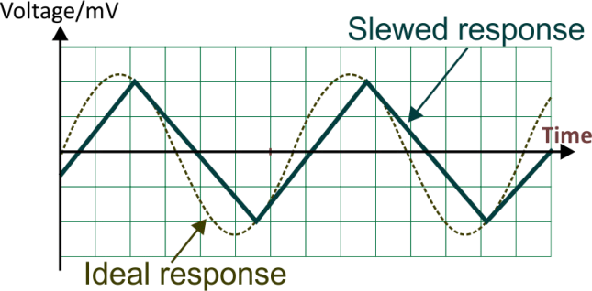
bigger amplitude.

However, at high frequencies, the output voltage may not be able to change fast enough to replicate the input signal. In that case, the output waveform may resemble that shown in the graph opposite.
The bigger the output voltage and the higher the frequency at which it must change, the greater the slew rate needed in order to follow the change.
When choosing an op-amp, the slew rate required to produce a distortion-free output can be calculated

using the formula:
slew rate
= 2 πf VP

where ‘f’ is the maximum frequency present in the signal and VP is the peak output signal voltage.

Example 1:

The table shows part of the data sheet for an op-amp.
Parameter | Value
Input impedance | 10 MΩ
Open-loop gain | 105
Output impedance | 100 Ω
Gain-bandwidth product | 1.2 MHz
Slew rate | 6 Vμs-1

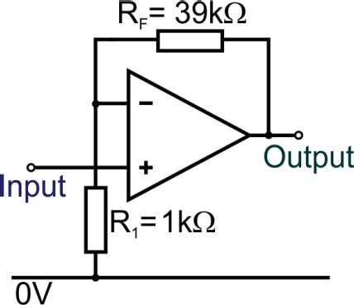
This op-amp is used in the non-inverting amplifier circuit shown opposite: The amplifier output saturates at ±12 V.
kK
kK
For this non-inverting amplifier, calculate:
- the voltage gain;
- its bandwidth;
- the two DC input voltages that just causes saturation;
- the time taken for the output voltage to change from +3 V to –3 V.

- Using the gain formula:
G = 1 + RF
R1
G = 1 + 39
1

G = 40

- Gain-bandwidth product = 1.2 MHz = 1 200 000 Hz.

Bandwidth =
1 200 000
40

= 30 000 Hz = 30 kHz
- Saturation voltage = ±12 V.
Voltage gain = 40 so output voltage is 40 times bigger than input voltage. Hence, input voltages that just causes saturation = ±12 V / 40 = ±0.3 V.

- Slew rate = 6 Vμs-1.
The output voltage can change at a maximum of 6 V in one microsecond. Changing from +3 V to –3 V is a change of 6 V.
This change will take 1 μs.

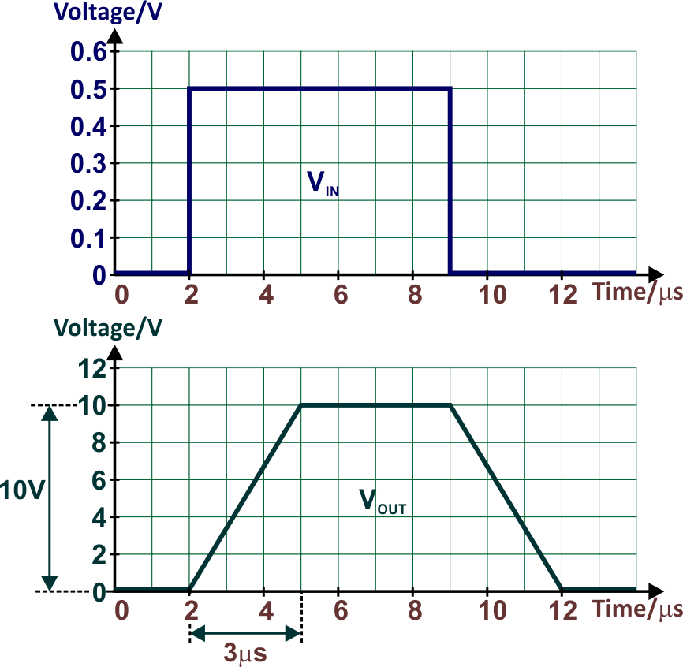
Example 2:

The graphs show how an amplifier output responds to a step input signal.
- Estimate the slew rate for the amplifier.
- Calculate the maximum signal frequency
that will produce distortion-free
output for a sinusoidal output of amplitude 10 V
- Using the formula:
slew rate = ΔVOUT
Δt
slew rate = 10 V
3 μS
slew rate = 3.3 V/μS = (3.3 × 10⁶ V/s)

The estimate for the slew rate is 3.3 V/μs.
- slew rate = 2 πf Vp
3.3 × 106 = 2 × π × f × 10
3.3 × 106
f = (2 × π× 10)
f = 52.52 kHz

Example 3:

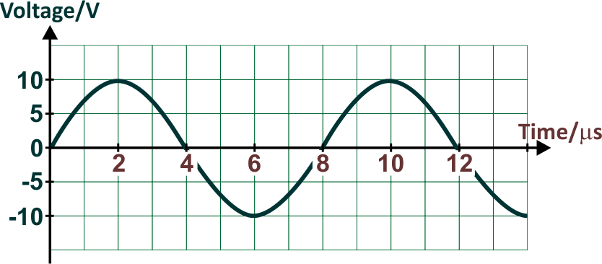
The graph shows the expected output of an amplifier based on an op-amp.

- Calculate the minimum slew rate required to achieve this.
- The amplifier output saturates at ±11 V.
Determine the maximum allowable voltage gain if input signals with amplitudes in the range ±140 mV are to produce a distortion-free output.
- The time period of the output is 8 μs.
Using the formula f = 1/T, this gives an output frequency of: 1/8 MHz, (= 125 kHz).
The peak voltage, VP, is 10 V.
Using the formula: slew rate = 2 πf Vp
= 2 × π × 125000 × 10
= 7.85 MV/s
= 7.85 V/μs
The minimum slew rate is 7.85 V/μs.

- Maximum gain
= 11
140 × 10−3

= 78.6

Where it is necessary to convert the gain to a whole number, it would be rounded down to again 78, since rounding up to 79 would cause clipping distortion.

Investigation 4.4

Set up the non-inverting amplifier shown below using a TL081 (or equivalent) op-amp
connected to a ±15 V power supply.
kK
kK

Note:

You will need either a storage oscilloscope or a PC oscilloscope such as PicoScope to carry out this investigation on breadboard. Alternatively, use simulation software.

- Connect channel 1 of the oscilloscope to the non-inverting input and channel 2 to the output.
- Press switch S for a few seconds. You will see the effect of slew rate on the output.
- Pause the display and measure the slew rate of the op-amp
You should find that it is in the range 6 to 10 V/μs.

- Replace the switch and resistor with a function generator, set to produce a sine wave input of amplitude 1 V (and a corresponding output of amplitude 10 V).
Use the formula: slew rate = 2 πf Vp
to predict the frequency at which slew rate distortion of the output starts to occur.

- Adjust the frequency of the input signal to about 30 kHz below this predicted frequency. Now, increase the frequency in 10 kHz steps until you observe a distorted output.

Record this frequency and comment on how well it matches your prediction.

- Adjust the input signal to a frequency of 10 kHz and amplitude of 2 V. Record the two saturation voltages of the output.

Exercise 4.5

- The following table is an extract from the data sheet of a typical op-amp.
Supply voltage / V | ±15
Input impedance / Ω | 4 × 106
Open-loop gain | 1 × 105
Max. output current /mA | 20
Gain-bandwidth product / MHz | 6
Slew rate / Vμs-1 | 1.3
Saturation voltage / V | ±13

  - Calculate the time it takes for the output to change from +13 V to –13 V when a large square wave signal is applied to the input.

...................................................................................................................................................
...................................................................................................................................................
...................................................................................................................................................

  - Resistors are added to produce a non-inverting amplifier with a voltage gain of 50.

    - What is the biggest input voltage that can be applied without saturating the output?

...................................................................................................................................................
...................................................................................................................................................
...................................................................................................................................................
...................................................................................................................................................
...................................................................................................................................................
...................................................................................................................................................

    - What is the bandwidth of this amplifier?

...................................................................................................................................................
...................................................................................................................................................
...................................................................................................................................................
...................................................................................................................................................

    - If the input voltage is increased to more than that in b) i), distortion occurs. What name is given to this effect?

...................................................................................................................................................

- The table gives some data about an op-amp.

Parameter | Value
Input impedance | 1.0 × 106 Ω
Open-loop gain | 1.0 × 105
Gain-bandwidth product | 3 MHz
Slew rate | 2 Vµs–1

The graph shows the characteristics of the amplifier built using this op-amp.
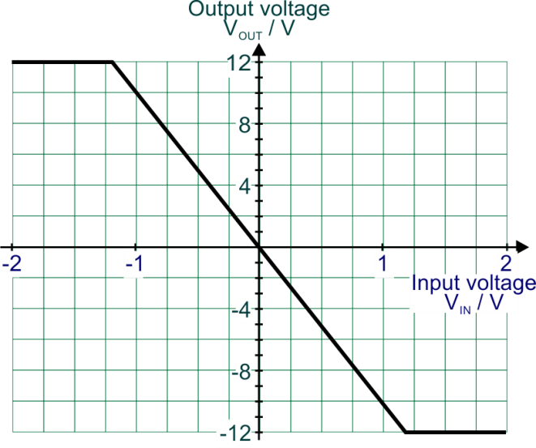

  - Use the graph to determine the voltage gain of this amplifier.

...............................................................................................................................................................
...............................................................................................................................................................
...............................................................................................................................................................
...............................................................................................................................................................

  - State the input impedance of this amplifier.

...............................................................................................................................................................

  - Calculate the bandwidth of the amplifier.

...............................................................................................................................................................
...............................................................................................................................................................

  - Calculate the time taken for the output to change from 0 V to 11 V in response to a large square pulse applied to the input.

...............................................................................................................................................................
...............................................................................................................................................................

...............................................................................................................................................................
...............................................................................................................................................................

Comparator
Learning Objectives:

At the end of this topic you should be able to:
- draw, recognise and recall characteristics of the op-amp comparator circuit;
- recall how the comparator output voltage depends on the relative size of the input voltages;
- select and apply the following equations for op-amp circuits:
VOUT = +Vs when V1 > V2 VOUT = -Vs when V1 < V2
- recall that an op-amp comparator has limited output current capability;
- design comparator switching circuits.

Introduction

A comparator is a sub-system that compares two voltages. Its output indicates which is larger.

One use of this is to turn an analogue signal from a sensing sub-system into a digital signal, in readiness for further processing. For example, a light-sensing unit can be connected to a comparator so that when the light level falls far enough, the output of the combined system changes from logic 0 to logic 1.

The Ideal Comparator

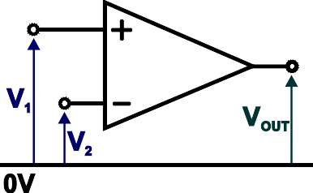
The circuit diagram for an op-amp configured as a
comparator is shown opposite:
It uses a single-rail power supply, with the negative power terminal, ‘–V’ connected to 0 V.
There is no feedback. The full open-loop gain, G0, of the op-amp is used to amplify the difference in the
input voltages V1 and V2.
From the formula: VOUT = G0 × (V1– V2)
this means that the output will always be saturated.
When V1 is bigger than V2, the output will be in positive saturation (in theory, +VS.) When V2 is bigger than V1, the output will be in negative saturation (in theory, –VS.)
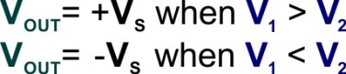
Expressed another way:

The Comparator Bridge Circuit

When used to interface a sensing sub-system to a digital circuit (or an output device), one of the input voltages is provided by the sensing sub-system.
The other input is a reference voltage, provided
usually by a resistive voltage divider.
The circuit diagram shows a typical arrangement. As the light level falls, the resistance of the LDR increases. As a result, input voltage V1 falls.
The components are set up initially so that input
voltage V1 is bigger than V2. Initially, then, the
output, VOUT, is in positive saturation.


When the light level falls far enough, V2 is bigger than V1 and the output switches to negative saturation. In terms of logic signals, in bright light the output of the op-amp is logic 1 and in the dark it changes to logic 0.

This behaviour is illustrated in the graph.
As the light intensity falls, V1 falls. To begin with, it is bigger than V2 and so the output is in positive saturation (equivalent to logic 1).

Eventually, V2 is bigger and the output switches to negative saturation (equivalent to logic 0).

The light level at which switching takes place can be adjusted by:

  - changing the resistance of the variable resistor VR to adjust voltage V1 at a given light intensity;
  - changing the relative values of resistors R1 and R2 to adjust reference voltage V2 since:

V2 =
R2
R + R

VIN

1 2

The reference voltage, V2, can be provided by a potentiometer instead of the resistor voltage divider, as the circuit diagram opposite shows:

The system described outputs logic 1 in bright light and logic 0 in the dark. This behaviour can be reversed
by:

- reversing the positions of the LDR and variable resistor;
- swapping over the op-amp inputs, so that the light-sensing unit is connected to the non-inverting input and the reference voltage to the inverting input

Note:

The problem of loading the sensor voltage divider does not occur with comparators since the inputs draw a
negligible current.

The Comparator in Practice

There are three issues that affect the performance of an op-amp as a comparator:

- Most op-amps have limited output current capability, typically sourcing or sinking up to ~30 mA. For many applications it is necessary to add a current buffer/driver, using a transistor or MOSFET to boost this current capability.
- For most op-amps, the output saturates before it reaches the power supply voltages.
For a power supply of +12 V / 0 V, the saturation voltages are typically ~10.5 V and ~1.5 V.
This means that a LED (and resistor) cannot be used to display the output state of the comparator – the LED glows no matter whether the output is in positive or in negative saturation.
- The open-loop gain of the op-amp is finite, but very large, typically 105.
Coupled with the information just given about practical saturation voltages, this means that the output does not switch to the opposite saturation state until the difference between the input voltages is greater than ~ 10–4 V (though the practical effect of this is marginal).

Some op-amps are designed to overcome these limitations.
For example:

- LM324/LM358 – have a negative saturation voltage of about 5 mV when operating on a single-rail supply, making the output compatible with logic gates.
They both offer an output current of about 40 mA.
The LM324 contains four op-amps on a single IC whilst the LM358 contains two.
- OPA548 – offers an output current of several amps.

Example 1:
kΩ

A temperature warning system includes an op-amp configured as
a comparator and a thermistor T.
The output of the op-amp saturates at +11 V and 0 V. The circuit diagram is shown opposite.

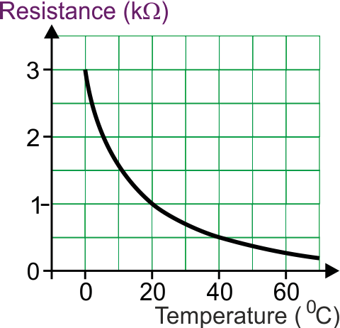
The characteristics of the thermistor are shown in the graph opposite.
Resistance/kΩ
Temperature/ºC

- What is the resistance of T at a temperature
of 20 °C?
- Calculate voltage V1 at a temperature
of 20 °C.
- The potentiometer is set so that voltage V2
is 4 V. Is the LED lit at a temperature of 20 °C? Explain the steps that led you to this answer.
- The potentiometer is adjusted so that the LED turns on when the temperature reaches 40 °C. What value of V2 is needed to achieve this?
- From the graph, at 20 °C, T has a resistance of 1 kΩ.
- Using the voltage divider formula:

V1 =
R2
R + R
VIN

1 2

V1 =
12 ×1
1+ 1

At 20 °C, V1 is 6 V.
- At 20 °C, the LED is off.
V1 = 6 V

The potentiometer outputs V2 = 4 V. At 20 °C, V1 is 6 V. V1 is bigger than V2 and so the output is in positive saturation and VOUT = 11 V.
- From the graph, at 40 °C, the thermistor has a resistance of 0.5 kΩ.
Using the voltage divider formula:

V1 =
R2
R + R
VIN

1 2

V1 =
12

0.5 + 1
× 0.5

V1 = 4 V
At 40 °C, V1 is 4 V.
At this voltage, the op-amp output should switch to 0 V (negative saturation) and turn on the LED.

For this to happen, voltage V2 should be just less than 4 V.

Example 2:

Design a control system that will switch on a lamp automatically at night. The design should include an op-amp configured as a comparator.
The comparator output should switch to positive saturation when it is dark. The light level at which the lamp comes on should be adjustable.
Complete the following circuit diagram for this system.
Do not include the lamp or any components used to buffer the op-amp to the lamp.

One solution is as follows:

Rationale:

- In daylight:
  - the resistance of the LDR is small;
  - the output voltage of the light-sensing unit is low;
  - the inverting input is at a higher voltage than the non-inverting input;
  - the output is in negative saturation.
- In darkness:
  - the resistance of the LDR increases;
  - the output of the light-sensing unit rises;
  - the non-inverting input has a bigger voltage than the inverting input;
  - the output is in positive saturation.
- The potentiometer controls the voltage at the non-inverting input. This determines how dark it has to be to force the voltage at the inverting input below that at the non- inverting input.
- The lamp is connected between the comparator output and the 0 V rail.

Investigation 4.5

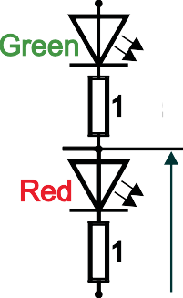
Set up the circuit shown below.
kΩ
kΩ
kΩ
kΩ
kΩ
- Adjust the light level on the LDR so that voltmeter V1 is reading as near as possible to 5 V.
- Complete the first row of the table below by recording readings of voltmeters V2 and V3. You should also state which LED is on.
- Repeat this process for the other values of V1 and complete the table.

V1 | V2 | V3 | Which LED is on?
5.0
5.5
6.0
6.5

- At what value of V1 does the comparator output go high? …………………….
- The red LED comes on when the light level is ……………
- The output of the comparator saturates at ……V and V.
- Complete the following statement:
The comparator is current when the green LED is on.
- Swap over the LDR and 56 kΩ resistor and comment on the resulting effect.

.............................................................................................................................

.............................................................................................................................

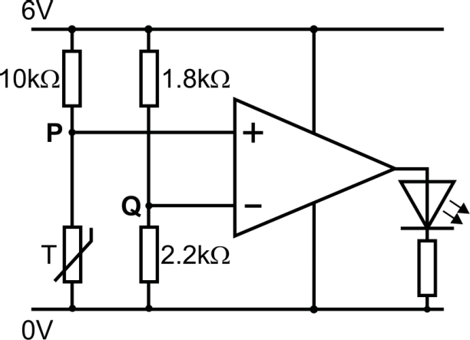
Exercise 4.6
kΩ
kΩ
kΩ

- The circuit diagram shows an op-amp used as
a comparator within a temperature indicator.

The resistance of the thermistor is:
  - 50 kΩ at 25 °C;
  - 5 kΩ at 100 °C.

The output voltage saturates at +5 V and +1 V.

- Calculate the voltage at point P when the temperature is:

  - 25 °C

  - 100 °C

- Calculate the voltage at point Q.

- Modify the diagram so that the reference voltage can be made adjustable.

- Draw a new circuit diagram for a temperature indicator which has the opposite function to the one given.

- a) Give two characteristics of an ideal comparator.

...............................................................................................................................................................
...............................................................................................................................................................
...............................................................................................................................................................
...............................................................................................................................................................

b) Design a control system that lights a green LED when the light is bright enough to play cricket, but lights a red LED when the light level falls too far.

The design should include a single op-amp configured as a comparator.

The light level at which the display changes from green to red should be adjustable.

Draw the circuit diagram for this system. You do not have to calculate and include resistor
values.

- A control system switches on a lamp automatically at night.

- The lamp is rated at 12 V, 50 W. Calculate the current through the lamp when it is working at full power.

...............................................................................................................................................................

...............................................................................................................................................................

- Design the control system which should be based on a comparator connected to a suitable driver circuit.

